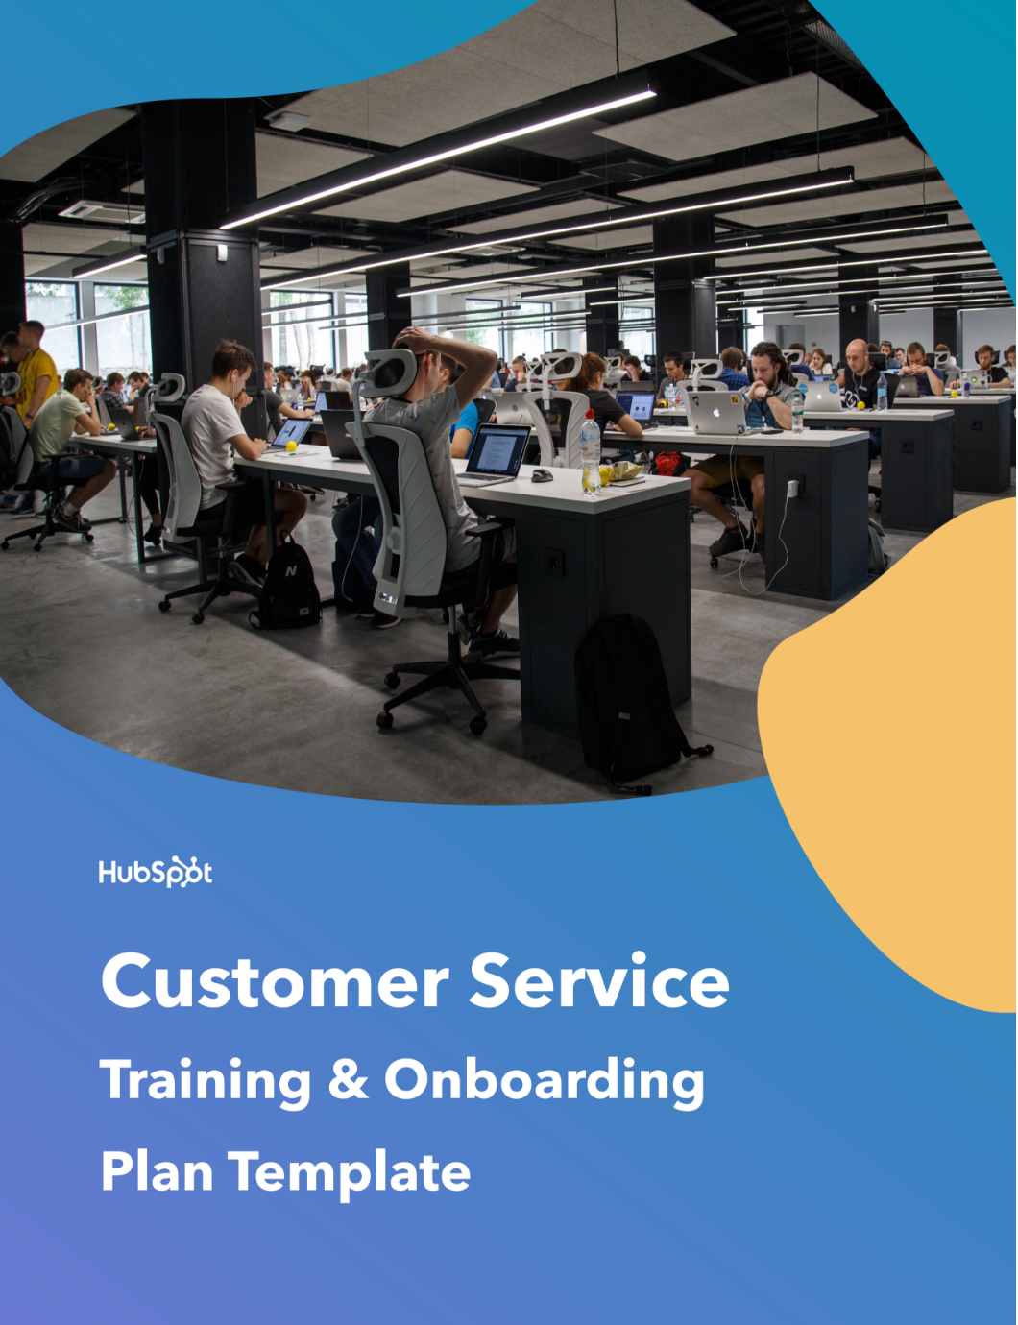

|  |
| --- |
| **Hi There.**  Thanks for Downloading This Resource. |
| ↓↓↓  How to Use This Template  Thanks for downloading HubSpot’s Customer Support Training Manual Template!    This tool was built for you to outline necessary training steps and information for new members of your customer service team. Included are sections common in most customer service training plans and manuals, as well as prompts for you to fill out your company’s tactics and information. We hope you find this template to be a useful starting point to build a unique onboarding process for your new customer service team members.    Simply erase the italicized instructions and examples in each section and replace them with what makes sense for your business.    Once complete, this plan can be used to help onboard customer service and support employees, plus anyone involved with customer success initiatives. Additionally, you can share it with anyone in your company looking to learn more about your processes.    Keep in mind, this template is designed to be completely customized by your company. If you feel there are sections included that you would rather omit, or if you think a section is missing, you’re encouraged to make those changes as you see fit for your business and new employees. |

|  |  |
| --- | --- |
| Need help putting your support plan into action?  Align your customer service team with  HubSpot’s Service Hub software. |  |
| [**Get Started With Service Hub**](https://www.hubspot.com/products/service?utm_source=offers&utm_campaign=ql-support-training-template) | |

(Keep scrolling to templates)

↓↓↓

**[Name] New Hire Guide**

* **Role:** *Enterprise Customer Support Specialist*
* **Manager/Reporting To:** *Name*
  + **Email Address:** *name@company.com*
  + **Phone Number:** *555-555-5555*
* **Department Head:** *Name*
  + **Email Address:** *name@company.com*
  + **Phone Number:** *555-555-5555*
* **Coach/Mentor:** *Name*
  + **Email Address:** *name@company.com*
  + **Phone Number:** *555-555-5555*

**Welcome!**

*Reinforce your excitement for this new hire to join your company. Remind the new hire that this is not a complete list of their role expectations, nor is it a contract. Instead, it is a collection of the fundamental tasks and resources to help the new hire ramp up, onboard, and succeed in his or her role long term.*

**Onboarding and Training Plan**

**Training**

*Provide the details for the new hire’s training, including:*

* *Timeline for training and schedules for specific sessions.*
* *Details on what each session/priority will entail.*
* *Expectations from training, such as a final project, presentation, or assessment.*

**Tech Set Up**

*Explain what technologies will be made available to the new hire to help in his or her role. If setup is required (i.e. connecting to the printer), provide instructions or name the individual/team who can provide instructions for setup.*

* *Computer/monitor information.*
* *Phone/headset information.*
* *Printer information.*

**Software and Operating Systems**

*Identify and link to the software required for the role. Provide setup instructions or resources for learning how to use the software, if necessary.*

* *[Customer Support Software](https://www.hubspot.com/products/service)*
* *CRM Software*
* *Company Wiki / Internal Documentation Software*
* *Video/Virtual Meeting Software*
* *Call Recording Software*

**Internal Communications**

*Should this new hire be on any email aliases/distribution lists? Are there any Slack or internal instant messaging channels to join? Is there a calendar or place to record vacation and time off? Outline those here.*

Email Aliases to Join

* *Example 1*
* *Example 2*
* *Example 3*

Slack Channels to Join

* *Example 1*
* *Example 2*
* *Example 3*

Calendars to Add

* *Example 1*
* *Example 2*
* *Example 3*

**People to Meet**

*Who are the people this new hire should connect with soon after starting? Provide the person’s name, role, and talking points to help make the 1:1 productive for both parties. See below for a few examples you may want to include.*

* ***Jon:*** *Director of Customer Support. We ask all new reps to meet with the department director. Use the time to get to know the history of the company’s support initiatives and get a better understanding of how you play a role in the department’s and the company’s goals.*
* ***Dany:*** *HR Business Partner, Customer Support. Dany will be your liaison for any HR or business inquiries in this department. Talk with her about how to best keep the line of communication open and what the best ways are to discuss any HR issues that may arise.*
* ***Brandon****: Product Manager. He will be your connection to the product team. Ask him what’s on the horizon for the next six months and what features the product team is most excited about. You can also reach out to him with any product-specific questions after you’re ramped.*
* ***Shae:*** *Director of Customer Support. Connect with Shae to learn more about innovations her team is making for proactive customer success and retention and ask how you can support those initiatives in your day-to-day.*
* ***Sam:*** *Customer Marketing Manager. Talk to Sam about how our company collaborates and interacts with customers outside of support to better understand their needs and personas.*

**100 Day High-Level Goals**

*At a high level, what do you want this new hire to be able to do by the end of his or her first 100 days?*

At the end of your first 100 days, you should be able to:

1. ***Be speedy:*** *Resolve tickets efficiently and kindly with only occasional assistance from your peers.*
2. ***Prioritize quality:*** *Achieve a personal Customer Effort Score average of 5 out of 7 or greater.*
3. ***Understand our company:*** *Fully understand our product suite and our customer.*
4. ***Master technology:*** *Fluently utilize our internal suite of support tools, helpdesk, and CRM software.*

**Month 1: *Date* - *Date*.**

*Month #1 is about getting started on the right foot. If you choose to set a case count goal, it should be small enough to enable the representative to develop an efficient workflow and spend time learning on the job. New hires should emerge from this month with knowledge of the product, company, support and case tools, and existing collateral to help new hires do their jobs (like a knowledge base).*

*Below, outline the* ***goal(s)*** *for month #1, what* ***deliverables*** *(if any) are expected, how success will be* ***measured****, and any* ***resources*** *that will help the new hire get his or her work done.* ***Remember that these goals are placeholders and should be replaced with your goals.***

**Goal**: *Learn our tone and brand voice while addressing support cases.*

**Deliverable / Measurement of Success:** *Read our company tone guide (linked below).*

**Resources:** *Company Tone Guide for Support Calls.*

**Goal**: *Understand our company and product.*

**Deliverable / Measurement of Success:** *Pass the new support hire assessment to demonstrate a baseline understanding of our offerings.*

**Resources:** *New Hire Study Guide, Knowledge Base, Product Training Team.*

**Goal:** *Understand the process of contacting support from the customer’s perspective.*

**Deliverable / Measurement of Success:** *Walk the case creation process through the customer’s shoes by contacting our company’s support line via email, chat, and email to grasp what the customer has to do to get the answers they need.*

**Resources:** *The “Contact Us” Page on Our Website.*

**Month 2: *Date - Date.***

*Month #2’s focus should be on putting month #1’s learnings into action. Expectations should be reasonable and depend on the new hire’s level of experience. It’s also a chance to apply early learnings of the product and support software into more in-depth scenarios requiring critical thinking. By the end of this month, reps should be on their way to resolving cases at the rate of a fully-ramped rep with high quality scores, but that rate and score should be reasonably set for your company.* ***Remember that these goals are placeholders and should be replaced with your goals.***

**Goal**: *Resolve your first ticket (in a group setting).*

**Deliverable / Measurement of Success:** *Closed ticket with a satisfied customer.*

**Resources:** *Your customer support team and manager.*

**Goal:** *Fully grasp the escalation framework for support redirects and transfers.*

**Deliverable / Measurement of Success:** *Achieve personal CES score of ## or greater.*

**Resources:** *Company Escalation Framework Flowchart.*

**Month 3: *Date - Date***

*The third month should see support reps springing into action. Make it clear that since the rep is fully ramped, and goals will start to become more aggressive and in line with other members of the team.* ***Remember that these goals are placeholders and should be replaced with your goals.***

**Goal #1:** *Resolve ## of tickets weekly with assistance only as needed.*

**Deliverable / Measurement of Success:** *## tickets closed.*

**Resources:** *Knowledge Base, Company Escalation Framework Flowchart.*

**Goal #2:** *Master our support tone and provide valuable advice and resolutions to our customers.*

**Deliverable / Measurement of Success:** *Achieve CES/NPS average of ##.*

**Resources:** *Company Tone Guide for Support Calls.*

**Feedback and Reviews**

*Outline your cadence for feedback and managerial reviews. Also, identify what should be prepared before these reviews, if anything. This would also be the section to explain how managerial 1:1s will take place.*

**Weekly 1:1s:** *Day of Week/Time*

**30-Day Check-In:** *Date*

**50-Day Check-In:** *Date*

**100-Day Review:** *Date. Please come prepared with your performance metrics to date and fill out the self-evaluation survey.*

**Role Guidelines and Best Practices**

**Anatomy of a Support Call**

*Outline the steps and structure involved in a typical support call for reps to follow. For example:*

*1.* *Greeting*

*2.* *Listening to Problem*

*3.* *Repeating Problem Back to Confirm*

*4.* *Looking for Solution*

*5.* *Providing Solution or Redirecting to Proper Person*

*6.* *Concluding Call and Thanking the Customer*

**Interacting with Customers**

*Provide a few best practices on how to interact with those who call in or email for support needs. This is especially important for rude, angry, or impatient customers. This is the perfect place to link to your company’s support tone guide.*

**Structuring Your Day**

*Since some support reps are responsible for handling cases over the phone, email, and chat, provide a breakdown of how reps should be structuring their workday.*

**Reporting and Tracking Your Performance**

*Explain what success looks like in this role. Provide a list of important metrics to know and how they’re tracked, such as NPS, CES and first call resolution.*

**Escalation Framework**

*Provide your company’s escalation framework to know when a situation should be escalated to management or transferred to a different rep. A list or a visual aid, such as a chart, would benefit this section.*

**Refunds, Returns, or Cancellations**

*Explain what justifies a refund or a return in your company, if applicable, and what response should be given when a customer asks for a refund when it is not permissible. This type of interaction usually requires explicit direction to new team members.*

**Product FAQ / Fast Facts**

*List some common questions that those ramping up have about your product or service, such as basic functionality clarifications plus fast answers to frequent support questions.*

**Appendix**

**Required/Suggested Reading**

*If there is any documentation or are any resources new hires should or must read, outline them here. These can be anything regarding company culture, role expectations, organizational leadership, or whatever is deemed mandatory. You could also style this as an FAQ section.*

* *Article on team outings.*
* *Article on expensing.*
* *Article on time off policy.*
* *Article on our relationship with sales.*
* *Article on our relationship with customer success.*
* *Video introduction from our CEO.*
* *Company annual goals.*

**Resources for Your Success**

*Identify the people, places, and things that exist within the company. These can be mentors and leaders, after-work groups, support hacks and tips, and more.*

* *Our #support-emergency Slack channel.*
* *Your mentor and your manager!*
* *Your product trainers.*
* *Our support best practices video series.*
* *Recordings of successful and failed support calls.*
* *Article on how to conduct a demo.*
* *Support Escalation Framework.*